Greco Feudal GDD

# Overview

## Summary

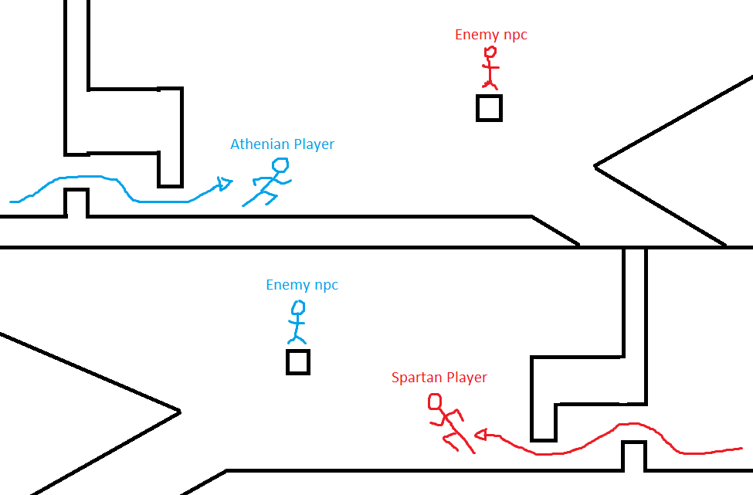2 players share a screen and run towards each other. They navigate a symmetrical map, facing enemies and obstacles along the way until they meet in the middle and have a climactic battle to decide a war.

## Pillars

1. Unique Culture Blend
2. Player vs Player
3. Rapid Gameplay

## Story

Athens and Sparta are in the midst of the Peloponnesian War, and it’s been going for long enough. The leaders of each nation, Pericles and Archidamos order their greatest soldiers (the players) to duel for the fate of the war.

## Aesthetic

Ancient times with a mix of Japanese and Greek culture. Inspiration from kung fu movies with the over-the-top action scenes and fast-paced editing.

## Unique Selling Point

* A blend of cultures that hasn’t been explored before. A mix of Greek and Japanese culture that creates a new and interesting aesthetic.
* 2 players facing off in a rapid approach and duel that tests skills like coordination, judgement, and reaction time.
* Symmetrical gameplay on a single screen and keyboard.

## Target Market

This game is targeted towards people that:

* Like ancient history
* Enjoy fast paced games
* Want competitive aspects in games
* Don’t have a lot of free time

# Gameplay

## Description

## Goals

The goal of each player is to reach the middle and beat the other player. Some sub goals within the game are:

* Find loot to increase advantage
* Dodge obstacles to not lose health

## Loops

# Mechanics

## Run

Player automatically runs forward at an unchanging speed which is uninterruptable.

* If they hit a wall or enemy they just lose health instead of coming to a stop.

## Jump

Player can jump to manoeuvre obstacles and change their path. There are no obstacles that can halt the player; only make them stumble to make them drop items. Any flat vertical surfaces will be broken through and any corners will be slide around so the player doesn’t stop.

## Slide

Player can slide underneath obstacles like small gaps.

## Dagger Throw

Player can attack mid jump to throw a dagger at the nearest enemy. It aims directly at them with no player input required.

## Slice

Player can slash forward and kill an enemy in one hit so as to keep the player running.

## Duel Showdown

Quick time event requiring the players to face off with accurate button presses.

# Controls

## Player 1

Jump – W

Slide – S

Slice – D

Dagger – A

## Player 2

Jump – Up Arrow

Slide – Down Arrow

Slice – Left Arrow

Dagger – Right Arrow